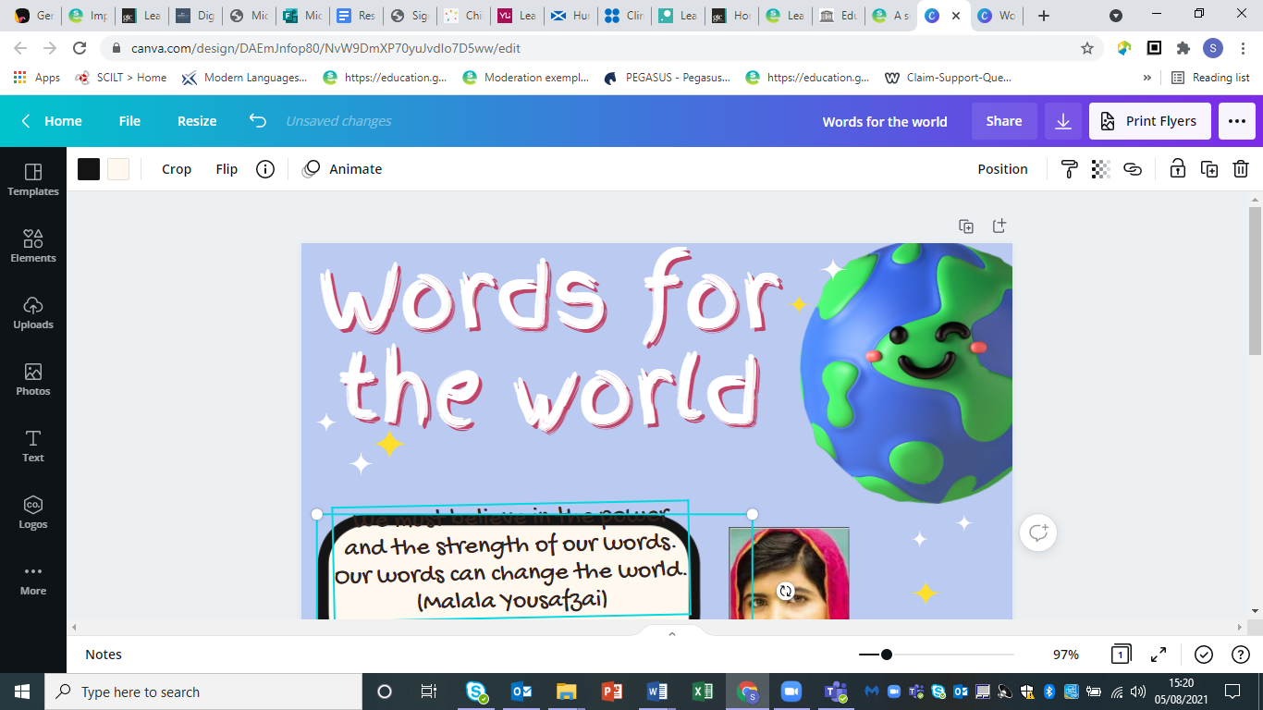

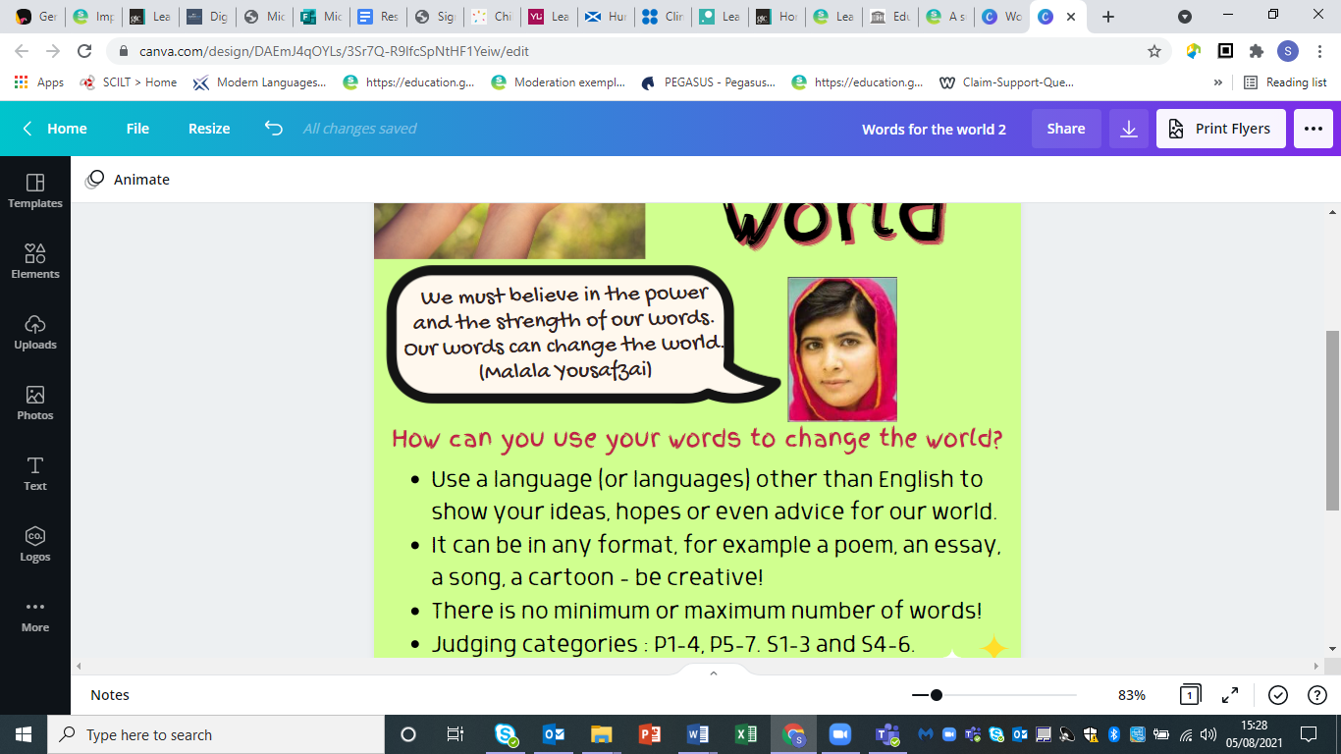

[Image from DFID](https://www.flickr.com/photos/dfid/14714344864)

Inspired by Malala’s words, we would love you to use your words to show how the world can be a better place.

Your challenge:

* For 2025, we have a new challenge for you! This year’s competition is focused on **Water**. World Water Day is on 22 March 2025, and several of the Sustainable Development Goals focus on water.
* Design and write a postcard to the First Minister to show how important water is in our world and what we need to do to look after it.
* There should be a hand-drawn design on one side of the postcard and a written message in a language (or languages) other than English on the other. *Note - Clicking on the left side of the postcard produces a text box which can be typed into to complete digitally (preferred) or the template can be downloaded and entries handwritten on it.*
* Judging categories: P1-4, P5-7, S1-3 and S4-6.
* Individual or group entries are welcome.
* Entries will be judged on language use, content and creativity.
* Guideline message length per age group:
  + P1-4 maximum 50 words
  + P5-7 between 50 and 100 words
  + S1-3 between 100 and 150 words
  + S4-6 between 150 and 200 words
* Closing date: **Saturday 22 March 2025**.
* Winners will be announced at an online event on Tuesday 29 April to tie in with Earth Day, observed on 22 April each year.
* Entries can be emailed by teachers to [scilt@strath.ac.uk](mailto:scilt@strath.ac.uk) with **Words for the World** in the email subject line.
* Each entry must:
  + - include a completed submission form and postcard template
    - include a completed consent form
    - be in a written format (videos may be submitted for BSL only)
    - conform to the copyright guidelines (see below)
    - state the school name, pupil name & age category in its file name
    - include a translation if the language is not usually taught within schools
* Teachers should include one completed teacher submission form detailing all entries from their school.

**Copyright guidelines**: pupils should not include any images, video clips or sound files taken from the internet which are covered by copyright. Inclusion of any such materials will mean SCILT cannot display the submitted entry. For further information on copyright, and suggestions of where pupils might find suitably licensed materials, please read the full guidelines [on our website](https://scilt.org.uk/CopyrightGuidelines/tabid/8572/Default.aspx).

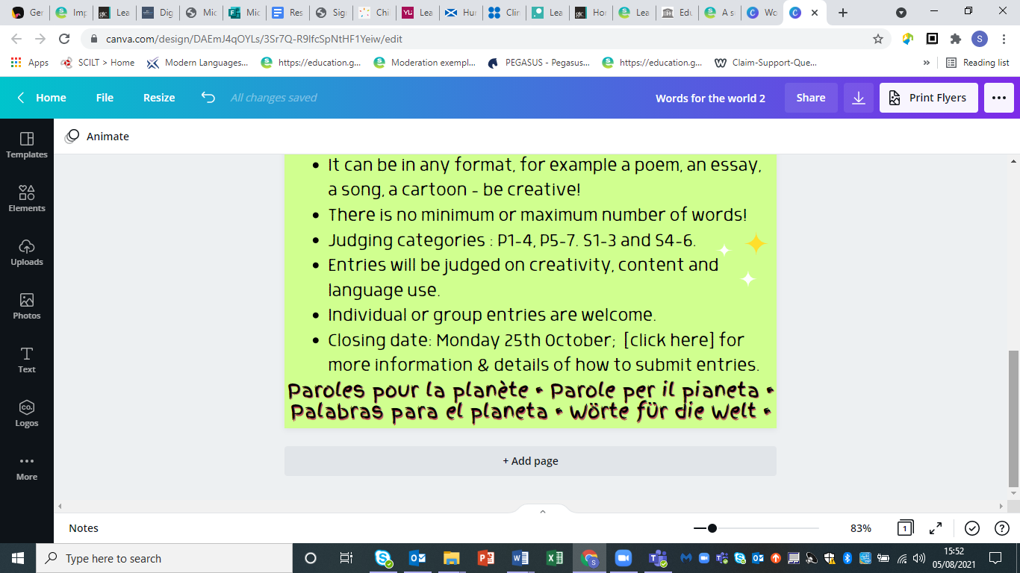We look forward to seeing your entries!